Student Guide: Healthy, Wealthy and Wise: Why Toilet Paper?
A Lesson in:
- Consumer Information
- Consumer Decisions
- Scarcity
- Supply and Demand
Before Reading:
1) You probably have either heard the news or seen memes about the toilet paper shortage. Check out how some people have been talking about the toilet paper crisis on social media by viewing the blog post or searching online. What do you think? Why do you think toilet paper is in such high demand? Why has it become a scarce resource?

2) Consider the title of the article by the Tampa Bay Times that we included on the blog: Nervous shoppers rear-end store shelves. What does the phrase "rear-end" mean in another context, like in a car accident? While you are reading consider why the authors used the term "rear-end" to describe what is happening.

During Reading:
3) While you read, search for answers: why has toilet paper become a scarce resource?

After Reading:
4) Check the notes you wrote while reading. What do you think about the toilet paper shortage? Why has it become scarce?

5) How much toilet paper do you think you need? Check out the toilet paper interactive HowMuchToiletPaper.com to figure out how much paper you need. Now create some mathematical models to figure out how much toilet paper different groups need.
Me | My Family | My Class | Other | Other
6) Now think of supply and demand in terms of toilet paper during this crisis. Use the Supply and Demand infographic from the Atlanta Federal Reserve to explain what happens when the demand of toilet paper is greater than the supply. Explain it below:

Conduct an online search for examples of price increases during this crisis. Many of the articles discuss "price gauging" as a recent unethical practice. To learn more about price gauging, read what Amazon is doing to unethical sellers who are participating in price gauging. What do you think about the recent price gauging? In your opinion, how is this different from regular practices of supply and demand? Use the OREO opinion-writing graphic to organize your thoughts. Then, create an opinion piece, social media post, public service announcement, or meme.

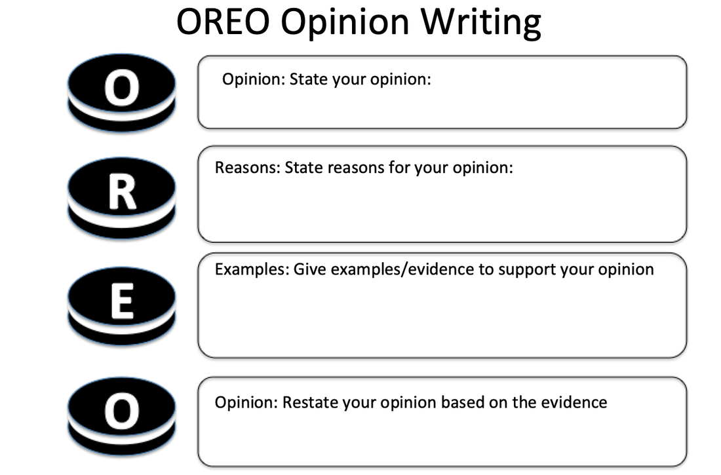Extension: In situations like this, do you think the government should intervene? Why or why not?

