Student Guide: Healthy, Wealthy and Wise: Will We Run Out of Food?
A Lesson in:
- Consumer Information
- Consumer Decisions
- Scarcity
- Charity
Activity 1
Before Viewing:
- Will we run out of food? This is a question that many people have asked during this crisis. Before you panic, this activity will help you find solutions. First, watch the video created by CBC Kids News

During Viewing:
- While you view, record some new things you learned from the student reporter.

After Viewing:
- What did you learn from the informational video? One of the problems is that people are hoarding vast amounts of goods. What are the consequences of this decision? How does this impact other consumers?

Now continue on with Activity 2

Activity 2
Before Reading

- Before viewing the video think: Why do you think Walmart shortened their hours?

- What did you discover? Walmart stated the shorter hours will "help ensure associates are able to stock the products our customers are looking for and to perform cleaning and sanitizing." How is this helping to protect the food supply?

- What goods has your family been buying? What are some of the goods your family might need?

Food we are buying | Food we might need

During Reading:
- Check out the Consumer Reports article for food and other goods that you might need. While you are reading, record these ideas. You can also search online for other suggestions from reputable sources.

After Reading:

- Conduct more research online. What are things the average family might need? After you complete your research, use the information writing sandwich graphic organizer to plan an article, public service announcement or blog post.
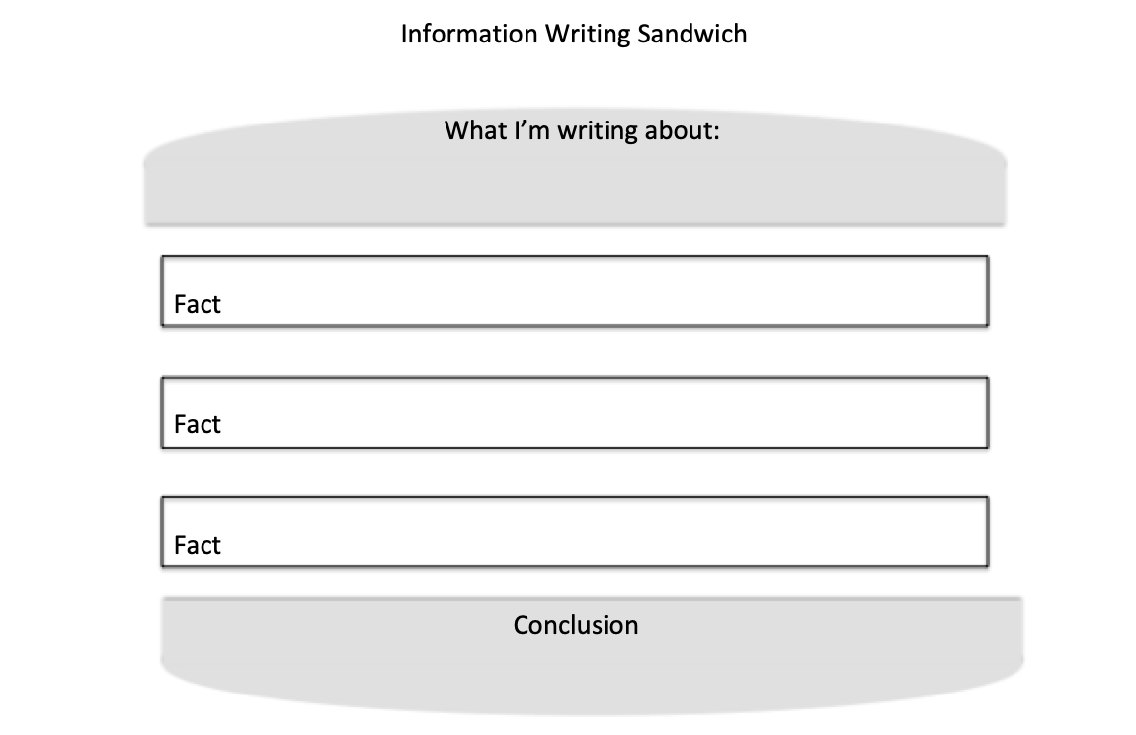

- Extension:
According to the Tampa Bay Times, thousands of local children rely on free and reduced-price meals ; for many, it is the primary source of nutrition. In the areas served by the Tampa Bay Times, you can find out how Hillsborough, Pasco, and Pinellas schools are helping these families. If you are in another district, search for your local newspaper online.
So what can you do? Check out what the Tampa Bay Times article to learn how to help local businesses and families. Then check out TheThomasPromise.org, a non-profit created by local Pasco student Brooke Thomas and her family. What is something you can do to help?

