Student Guide: Why Should I Care About the Economics of the Coronavirus?
<Blog Post Date: March 20, 2020>
A Lesson in:
- Economic Conditions Affect Income  - Consumer Decisions | • Willingness to Take Risk  • Government Providing Information to Consumers
Before the Reading:
- Riddle me this: What has the power to double in size every 3 days, yet it cannot be seen with the naked eye?
Answer: SARS-CoV-2, the new strain of coronavirus. (COVID-19 refers to the disease that the new coronavirus (SARS-CoV-2) can cause; which broke out in 2019.)

- Riddle me this: What lock gives more and more freedom the stronger the lock?
Answer: A lockdown. The more people who participate in voluntary lockdowns (or “social distancing”) will provide a slower spread of disease and additional freedom from sickness. The slower the spread of any sickness, including the Coronavirus allows medical personnel to help those who need it most. Social distancing helps to “flatten the curve.”

- So, what does it mean to flatten the curve, and what does it have to do with economics? Have you ever experienced a conversation in which you felt like you needed a dictionary or thesaurus just to keep up? Maybe a translator to help you understand the language that was used? Use your background knowledge of the coronavirus and predict what you think medical personnel and government officials are referring to when they use “curve.” What does it mean to “flatten the curve?”
My Predictions:
Curve: | Flatten the Curve:

- Nothing new here? Remember the days of chickenpox? Or maybe your generation has received the vaccine shot to thwart this childhood illness that was once unhealthily considered a “rite of passage” to children until the mid 90’s. How different is this new strand of the Coronavirus to the old one, or to the common cold for that matter? How similar is the chickenpox to the coronavirus? Go online to research how each spread. What do you find?
Spread of disease: Chickenpox | Spread of disease: Coronavirus
- Graphs solve the world’s problems. Just kidding. But they sure do make life easier! Check out a quick graph to compare the new coronavirus to other infectious diseases. https://www.nytimes.com/2020/02/18/learning/whats-going-on-in-this-graph-coronavirus-outbreak.html
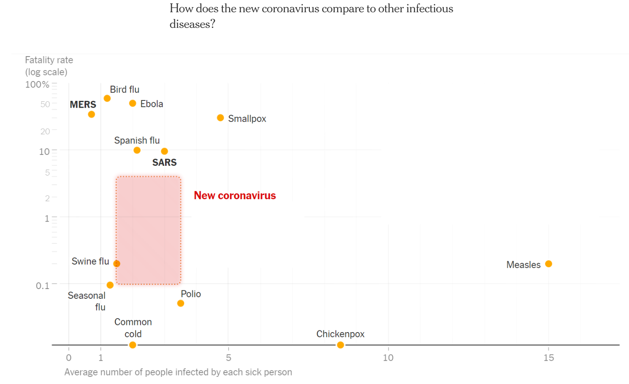
What have you discovered? What surprises you about this chart? How familiar are you with these other infectious diseases? Does what you think you know match the data?
My discovery:

Coronavirus Similarities: | Coronavirus Differences:

- Wash your hands. Shouldn’t we all just keep to washing our hands and staying home if we are the ones who are sick- just as we did before this pandemic? What is the big deal? Based upon your answers to the last two questions, why is washing your hands alone not enough?

During the Reading with Newspapers in Education:
- An inside look at the Florida economy. Read through the article Coronavirus in Florida latest: Statewide closings, new cases, flattening the curve by Tampa Bay Times posted March 18, 2020. You can learn about what is making some business owners and parents nervous as well as identify some economic issues at hand. https://www.tampabay.com/news/health/2020/03/18/coronavirus-in-florida-latest-statewide-closings-new-cases-flattening-the-curve/ As you are reading, write down something the article shares about each of these economic ideas:
Economic Idea: | Article’s comments:
Florida government says: “No visitation” | - Might the government have access to information that the public has? Why may these changes have been made?
Governor Ron DeSantis orders: | - Why has the government chosen to intervene? Who is the government defending?
Revenue: | - What changes may business owners see in the near future? How do you know this?
Customers: | - What is changing between the relationship of supply/businesses and demand/consumers?
Government assistance: | - What responsibility does the government have to help businesses?
School cancellation: | - How will these changes in education affect households? What about teachers?
Mr. Rogers’ quote: | - Why do some people choose to help?

After the Reading:
- Back to the curve. The end of the article hints at flattening the curve but doesn’t say how or what that infamous curve even is. If you have time, you can access the article’s link to the suggested news podcast. For now, take a peak at how Mydel Antolin explains “flattening the curve” on CBC’s Kids News. https://www.youtube.com/watch?v=ZqWrPWmeDK4 What does that curve look like if you had to draw it…. How would you flatten that curve?
Draw the curve discussed in the CBC clip: | Ideas on how to flatten the curve:

- Compare. Statnews provides an excellent video clip to show just what that flattened image would look like. https://www.statnews.com/2020/03/11/flattening-curve-coronavirus/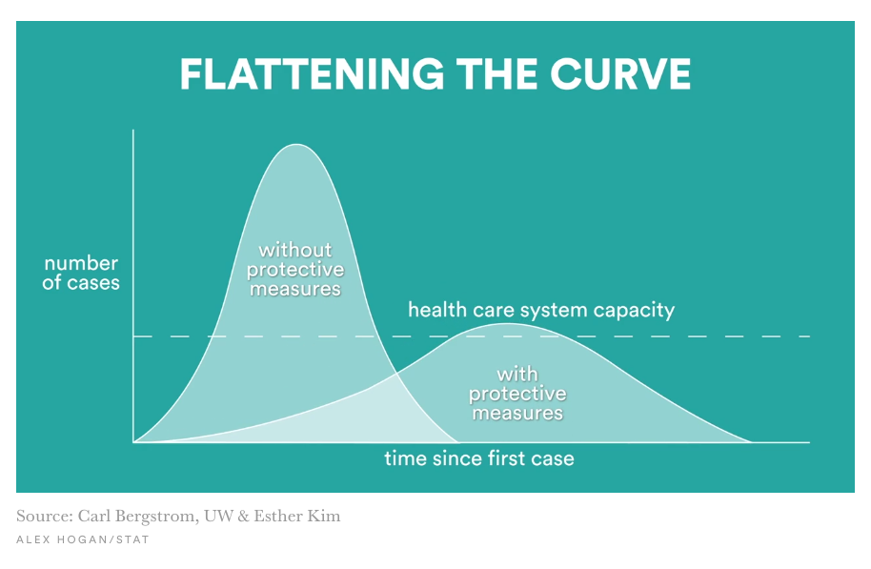
How does your image compare to the Statnews image?

- The How To: The best step-by-step guide on how to flatten the curve is “Why outbreaks like coronavirus spread exponentially, and how to “flatten the curve.” https://www.washingtonpost.com/graphics/2020/world/corona-simulator/ Author Harry Stevens is a graphics reporter who creates some pretty cool simulations to teach Washington Post readers just how effective “social distancing” really can be. Watch each of the four simulations and feel empowered to spread the news on just what flattening the curve is, and why all Americans should participate. Jot notes on what each of these simulations mean.
Simulation 1: Free For All | Simulation 3: Moderate Distancing
Simulation 2: Attempted Quarantine | Simulation 4: Extensive Distancing

- Where are we? Make an educated guess on where America is relative to these four simulations. What about China? What about France and Italy?
Extension: Create a political cartoon to teach younger students about flattening the curve or economic issues of the coronavirus.

