Student Guide: Healthy, Wealthy and Wise During COVID-19: How does it impact me?
A Lesson in:
- Consumer Decisions
- Scarcity
- Charity
Activity 1: First Video on Teens React to the Coronavirus . . .
Before Viewing:
- Consider: How has COVID-19 impacted your life? What are some of the consumer choices you have had to make? Have you noticed any scarcity problems?
During Viewing:
- While you view the Teens react to the coronavirus video, record some new things you learned from the student reporter.

After Viewing:
- This video was made by teens in Canada. What are similarities and differences with the impacts you have felt in the place where you live?
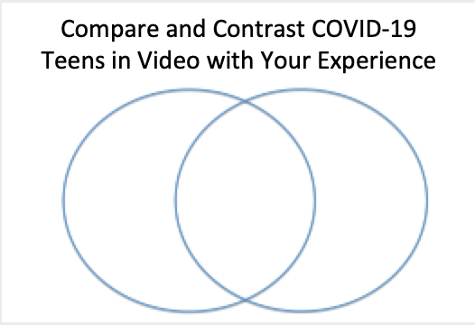

- What was the first thing that made you realize that COVID-19 was a big deal?

Now continue on with Activity 2

Activity 2
Before Viewing: How has COVID affected sports?

- The COVID-19 pandemic has created financial and social-emotional consequences for many individuals. How has it impacted you? How have your buying choices been impacted? What about event cancellations? For example, were you impacted by concert or sports cancellations?

During Viewing:
- Watch the Tampa Bay Times Newspaper in Education News Video on Sports and COVID-19. While you watch the video, record some of the impacts on sports.

After Viewing:
- How were you personally impacted by sports cancellations? How were others impacted?

Impacts on me | Impacts on others

- Consider the players and all of the people who work at the stadiums. What are the costs and benefits of closing stadiums during the pandemic?
Costs | Benefits

- There have been many news articles about how sports players and team owners have been helping the workers who have been impacted. Search the news and find some articles and videos about players or team owners who have supported the laid-off workers. How do you feel about the teams who support the workers? Find other examples of people who are doing good things for others during these hard times. Create a social media post about someone you caught doing #COVID-19GoodDeeds.

