Student Guide: Healthy, Wealthy and Wise: Fake News and Finding Facts in the COVID-19 Crisis
A Lesson in:
- Consumer Information
- Consumer Research
- Consumer Decisions
There are two short activities in this guide:
Activity 1:
Before Viewing: In a world of online sources, it is sometimes difficult to distinguish the COVID-19 facts from the fake. Have you heard rumors about COVID-19 cures?

During Viewing: Check out the news video of the week from Tampa Bay Times NIE. What happened when the U.S. Customs and Border Protection agents found counterfeit coronavirus test kits at the O'Hare International Airport.

After Viewing:
What happened? Why do people create and sell fake test kits? What is your opinion about what they did? Use the OREO opinion writing graphic organizer to plan an opinion piece.

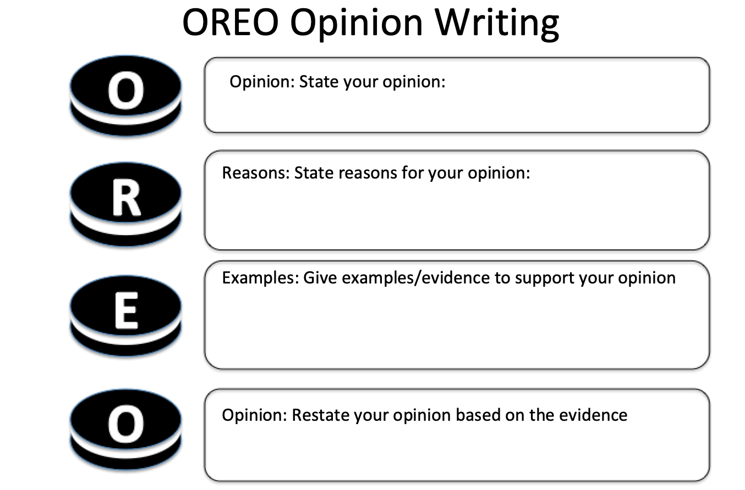
Activity 2:
Before Reading: What have you heard about Fake News that is spreading about the Coronovirus?

During Reading: Check out the Tampa Bay Times article: Hoaxes Spread Coronavirus Fears. What are some of the hoaxes? Sometimes spreading rumors online can have negative unintended consequences. What are some of the possible unintended consequences of these hoaxes and rumors spreading through social media?
Hoaxes | Possible Unintended Consequences

After Reading:
- How can you protect yourself from scammers who are trying to profit from the COVID-19 pandemic?
- Did you notice that the Tampa Bay Times turned to Politifact to determine facts from fake? What are some reliable sources in these uncertain times? If you want to have the most current and reliable information, check: Center for Disease Control (CDC) and World Health Organization (WHO) .
- Then, check out the video by student reporters at CBC. What new facts did you learn?

- Now, conduct some of your own research online. Find a couple of articles and use the strategy recommended by reporters and researchers: Lateral Literacy. Reading laterally means checking the truth and accuracy of the source (reading laterally) before reading the article (reading vertically). Find some article about COVID-19 online and use this when you are conducting your own research!

A: Who is the author and is there a motive behind the message?
A: What can you learn about the author?
A: What biases might the author have?
R: How recent is the article/site? When was it published/updated?
R: What do fact-checking sites say about the author and claim?
T: Who is the audience and why was the author targeting them?
T: What does the author want the audience to believe, take a stand against/for, or purchase?
You can also use some of the fact checking sites at the bottom of the post.
5) Record new facts you learned. Also, document some of the fake news that is out there.
Facts | Fakes
6) Now, create your own video, article, or social media post to warn people about fakes and teach them about the facts! What are the possible economic consequences of some of these fakes?

