Student Guide: What do consumers need to know about security camera hacks?

A Lesson in:
- Consumer Information
- Consumer Decisions
- Decision-making
- Risks

Before the Reading:

- Fear Factor. What happens when your smart home technology take on a mind of its own? Imagine sitting in your living room and hearing a mysterious voice on your Amazon Ring or Google Next speakers! How do you think this could happen?

- Examine the Title and Predict. Before you read the Tampa Bay Times NIE Front Page Talking Points: What Consumers Need to Know About Security Camera Hacks, think about what the article might be about, based on the title. For example, what is a hack and how can it be related to security cameras?

During Reading:

- The Real Issue. While you read, take not of things you think a consumer needs to know about security camera hacks.

After Reading:

- What did you discover?

- What do you think? How does this information impact you as a consumer? Record some of your reasons to buy and not to buy in the table.
To Buy | Not To Buy

- What would you do? Based on what you learned, would you choose to buy or not to buy? Why?

- Opportunity Cost. The opportunity cost is the next best option you did not choose when you made another choice. What was the opportunity cost of your choice?

- Online research. Conduct some online research about security cameras. How does research impact buying decisions?

- Watch the video. Now check out the news video about the same story. While you watch, take more notes.

- Examine Perspectives. Now check out the perspectives of three different stakeholders. Analyze their comments, based on the evidence you found.
Ring (the company) says: "Ring believes when communities and local police work together, safer neighborhoods can become a reality." -- Yassi Shahmiri, company spokeswoman | Critic (a technology expert) says: "Ring should be shut down immediately and not brought back. The privacy issues are not fixable with regulation, and there is no balance that can be struck. They are simply not compatible with a free society." – Max Eliaser, Amazon engineer | Journalist says: "I spent a couple weeks using an Amazon Ring doorbell camera. I didn't like how it made me feel about my neighborhood, or how i thought it might make my neighbors feel about me." – Max Read, New York magazine writer and editor
- Create an argument. Which perspective do you think most fits the evidence you found in the article, video, and other online research you conducted? Do you agree with any of the three perspectives or did you create your own perspective, based on the evidence you found? You can use the graphic organizer below to build an argument. Then, you can either write an argument essay/blog post or have a debate with some friends or family members.

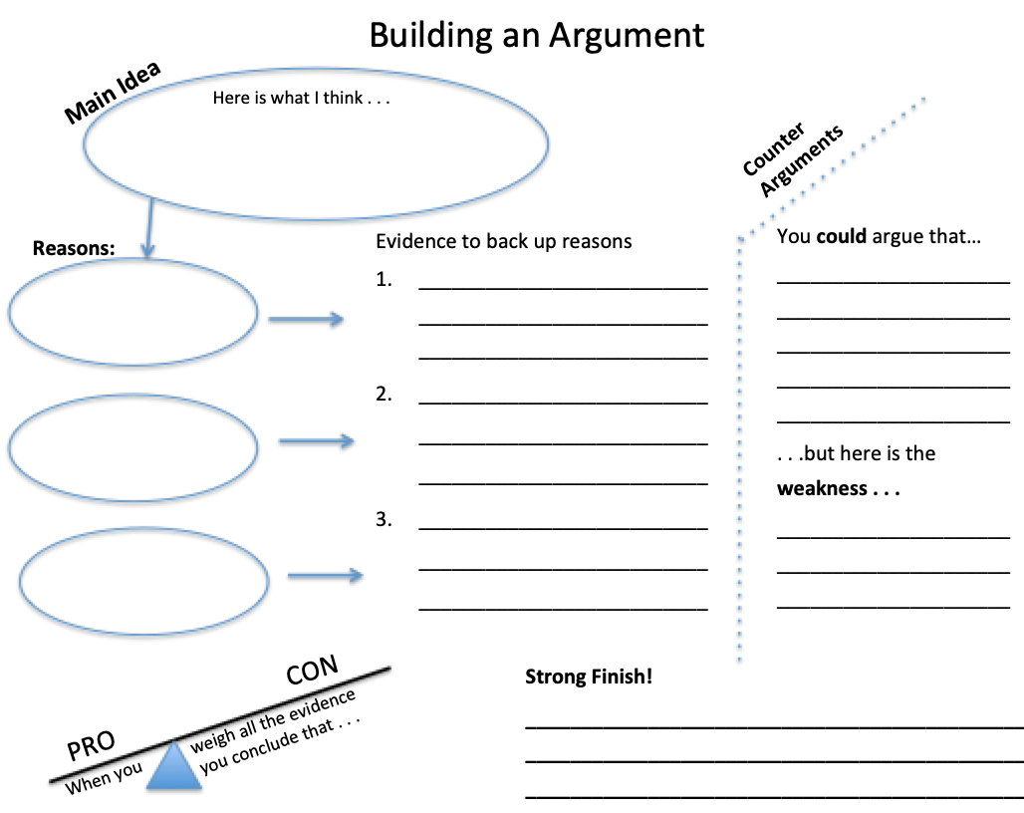

Extension: What do you think the government’s role should be in cases like this?

