“How Do People Save for the Future?” Student Guide
A lesson in:
- Consumer Risk
- Risk Events Subject to Error
- Preference to Accept Risk

Movie Gif: Disney’s Princess and the Frog Engagement:
Take a look at the gif attached and answer the questions that follow.
- Tiana's Money

What do you see? | How do you think Tiana acquired all of this money? | What do you think the money is for? | How long may it have taken to let this money accumulate?

The Sisters & Disney blog wrote in The Princess Purpose: Tiana, “Tiana is an ideal example of what it is to work hard. In order to reach her dreams of owning her own restaurant, she has the determination to save up money and is willing to sacrifice fun nights out with friends in order to reach her goals…. In her movie, Princess and the Frog, she’s told that wishing on stars isn’t enough; you have to work for your dreams. She wishes, she works, she sacrifices. And in the end, through all her hard work, she ultimately reaches her goals, and owns her own restaurant.”

- Have you started saving money for a “dream” of your own?

- What have you been saving for- or what do you see yourself saving for soon?

- How long have you been saving money for?

- How long do you think it will take for you to reach your goal?

- Will this be an easy task for you? Why or why not?

Your Thoughts Before Reading:

People save for a variety of reasons. Scrutinize the image below.
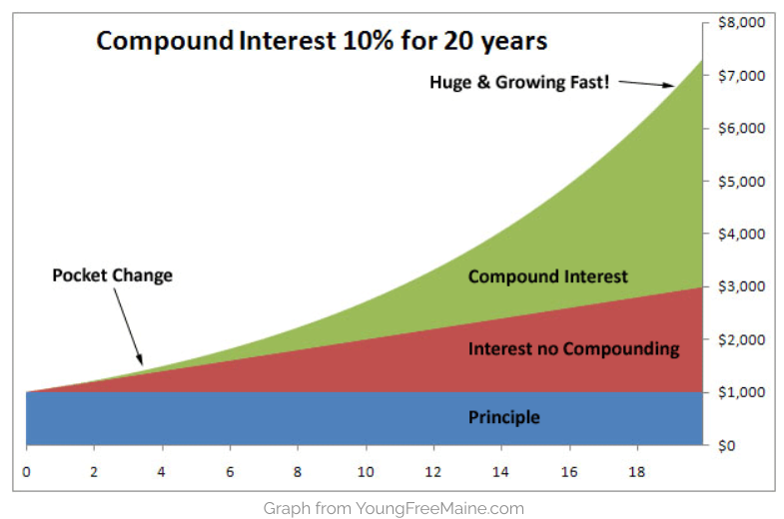

Multiply it! If those who save money choose an account which bears “compound interest” (instead of interest alone), their saved money can multiply faster. Many save for large future purchases such as higher education, vehicles, homes, retirement, and unexpected events. What do you notice about this graph? Do you have any questions?

Reflect. When was the last time someone asked for your advice, and then completely ignored it? Have you ever asked for advice from friends or family and then went on about your business as if you had never asked for advice at all? Share a time that you can remember.
- Grin and bear it. Explain why you think people commonly ask for advice, but ignore it? Is this using wisdom? Are there any times in which it is smart to ignore “advice?”

It’s “Cringy.” Some financial planners cower at the thought of these “ignored experiences” on a regular basis. Why go through all of the hassle of finding someone with great skill and knowledge in financial matters only to make their huge monetary investment (or lack thereof) decisions alone? People seem to prefer to ask questions, but ignore the answers.
Why do people tend to underestimate their need to protect themselves financially? Do you tend to make decisions with your money on your own, or do you ask questions?
- Identify a trustworthy financial mentor. What credible person do you ask for financial advice from? Do you tend to follow their advice or ignore it?

- Money Mentors. Make a short list of three financially savvy people you would feel comfortable asking financial questions to. (Those who have your best interest at heart.)
1. | 2. | 3.

During the Reading with Newspaper in Education:
- Read through the attached article:”Investing Advice from a Pro.” As you read, make a list of financial decisions that responsible adults need to make with their money. Mark the items with a star that you will need to consider within the next year. Categorize these decisions with titles such as insurance, investment, and spending, etc. Try and match the list of the people you trust to help you make financially smart decisions with the type of financial decisions you will consider this upcoming year.
Financial Decision | Category | Mentor
1.

2.

3.

4.

After the Reading:
- Share. Review your decisions above with a partner. Examine your partner’s list of upcoming financial decisions and provide a suggestion or two for your partner to consider in the upcoming months.
- As a Class. Think Forward.
What does it mean for some people to accept risk, while others reject it? | Why will some people pay a small financial cost now to avoid a possible larger financial loss later?

Extension: On a 3x5 card, make a “quick guide” for yourself when making smart decisions with your money. Use the article to lead you in your financial decision making chart.

